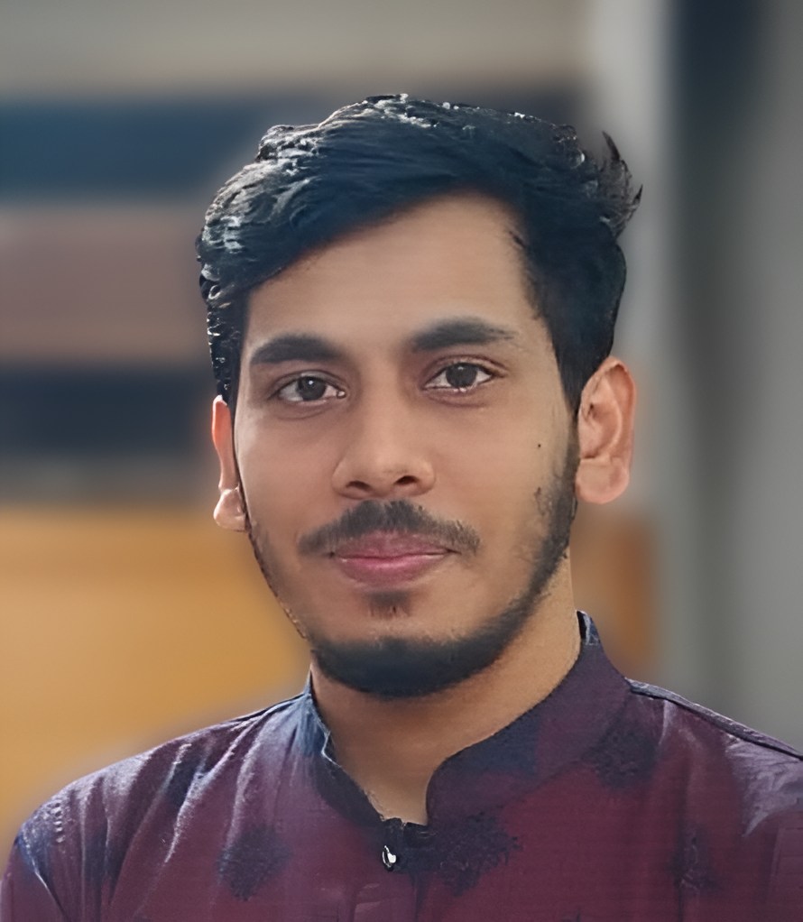



Linkedin.com/in/hasnattanvir



https://github.com/hasnattanvir



hasnattanvir014@gmali.com



+088 01972918629

**ABUL HASNAT**

Web Developer Professional

**ABOUT ME**

**WORK EXPERIENCE**

**3 Years**

6 Years

Am a hard working, honest individual. I am a good timekeeper, always willing to learn new skills. I am friendly, helpful and polite, have a good sense of humour.I am able to work independently in busy environments and also within a team setting. I am outgoing and tactful, and able to listen effectively when solving problems.

**AGE**

29



**Education**

**B.Sc. in Computer Science & Engineering** Graduated August 2, 2022Dhaka International University. GPA 3.30  
Dhaka, Bangladesh CSE

**Diploma in Electronics Engineering** Graduated Apr 2016Noakhali Ideal Polytechnic Institute. GPA 3.14  
BTEB Electronics  
Noakhali, Bangladesh

**Secondary School Certificate** Graduated 2012Miar Hat high school GPA 2.50  
Cumilla Board Humanities  
Noakhali, Bangladesh



**Professional Qualifications Affiliations**

* Proficient in WordPress development, theme customization, and plugin integration.
* Skilled in HTML, CSS, and JavaScript for front-end design and development.
* Knowledgeable in responsive web design for optimal viewing experiences across devices.
* Strong problem-solving abilities and attention to detail in coding and troubleshooting.
* Proven ability to meet project deadlines and deliver high-quality work under pressure.
* Excellent communication skills, facilitating effective collaboration with clients and team members.



**Skills**

* WordPress Theme Development.
* Plugin Customization.
* Theme Customization.
* Responsive Design.
* Cross-Browser Compatibility.
* WordPress Coding Standards.
* Performance Optimization.
* Testing and Deploy.
* Git Control

Note: "I'm a part-time work develop in React, React Native, Node.js, Laravel, and Ruby, with a knack for juggling multiple projects. Specializing in flexible, part-time engagements, I bring a versatile skill set to each endeavor, from front-end development with React to back-end proficiency with Node.js, Laravel, and Ruby frameworks."



**Work Experience**

**Company Name:**  DUSRA Soft Limited.

**Company Location:** Dhanmondi, Dhaka-1209

**Designation:** Web Developer.

**Job Experience Time:** 3 Years

**Job Start Date** - 01.07.21



**Languages**

* Bangla: Mother Tongue.
* English: Fluent in Feeding, Writing & Spoken Mid Level.



**Personal Interests**

|  |  |
| --- | --- |
| * Traveling. | * Play Badminton |
| * Listening islamic lecture. | * Writing short stories. |
|  |  |



**Personal Details**

**Name** : Abul Hasnat. **Place Of Birth** : Noakhali, Bangladeshi.

**Nick Name** : Tanvir. **Father’s Name** : Abul Basar.

**Nationality** : Bangladesh. **Mother’s Name** : Mrs.Khaleda Akter.

**Blood Group** : B + (ve). **Birthday** : October 25, 1996.

**Marital Status** : Single. **Religion** : Muslim.

**Height** : 5 Feet 7 Inch.

**Permanent Address** : village- South Nazir Pur (area code-1097), **P.O**: Dinmonir Hat, Post Code: 3803 **P.S**: sadar, **District**: Noakhali, Bangladesh.

**Present Address** : House #227/2/A, Chistiya Mongil Rode, Modhubazar, West Dhanmondi, Dhaka.

**Declaration**

I, Abul Hasnat, hereby declare that the information contained herein is true and correct to the best of my knowledge and belief.





------------------

Signature